**VISVESVARAYA TECHNOLOGICAL UNIVERSITY**

# “JnanaSangama”, Machhe, Belagavi, Karnataka-590018

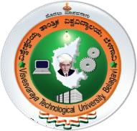

AICTE Activity Point Program Report On

Activity 1: Provided Educational Assistance for School Children to Secure Good Academic Results.

Activity 2: Awareness on Swachh Bharath Abhiyan.

Activity 3: Awareness program on COWIN app

*Submitted in partial fulfillment towards requirements for the award of the degree of*

# Bachelor of Engineering

in

# Electrical and Electronics Engineering

Submitted by

# PREETHI B S (4GW19EE028)

Under the Guidance of

# Mrs. SHILPASHRI V N

Assistant Professor Dept. of EEE, GSSSIETW



# DEPARTMENT OF ELECTRICAL AND ELECTRONICS ENGINEERING

(Accredited by NBA, New Delhi, Validity:01.06.2021-30.06.2024)

# GSSS INSTITUTE OF ENGINEERING & TECHNOLOGY FOR WOMEN

(Affiliated to VTU, Belagavi, Approved by AICTE, New Delhi & Govt. of Karnataka) KRS Road, Metagalli, Mysuru-570016, Karnataka.

(Accredited with Grade ‘A’ by NAAC) 2023

***Geetha shishu Shiksha Sangha (R)***

# GSSS INSTITUTE OF ENGINEERING & TECHNOLOGY FOR WOMEN

(Affiliated to VTU, Belagavi, Approved by AICTE, New Delhi & Govt. of Karnataka)

KRS Road, Metagalli, Mysuru-570016, Karnataka (Accredited with Grade ‘A’ by NAAC)

# DEPARTMENT OF ELECTRICAL AND ELECTRONICS ENGINEERING

(Accredited by NBA, New Delhi, Validity:01.06.2021-30.06.2024)



This is to certified that the AICTE Activity Point Program titled **Activity 1: (Provided Educational Assistance for School Children to Secure Good Academic Results) Activity 2: (Awareness on Swachh bharath Abhiyan), Activity 3: (Awareness program on COWIN app)** is a bonafide work carried out by **Preethi B S (4GW19EE028)** in partial fulfillment for the award of degree of Bachelor of Engineering in **Electrical & Electronics Engineering** of the Visvesvaraya Technological University, Belagavi, during the year 2022-2023. The report has been approved as it satisfies the academic requirements with respect to the AICTE Activity Point Programme prescribed for Bachelor of Engineering Degree.

Signature of the Guide Signature of the HOD Signature of the Principal

Mrs. Shilpashri V N Dr. G Sreeramulu Mahesh Dr. M. Shivakumar

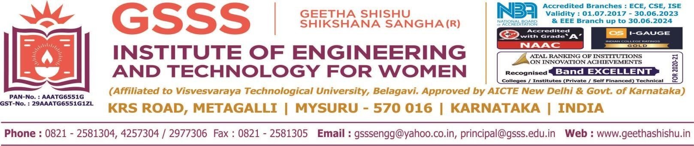

**DEPARTMENT OF ELECTRICAL AND ELECTRONICS ENGINEERING**

**ASSESMENT RECORD**

NAME: PREETHI B S USN: 4GW19EE028 SEMESTER: VII

|  |  |  |  |  |  |  |  |
| --- | --- | --- | --- | --- | --- | --- | --- |
| **Activity No** | **Title of the Activity** | **Date** | **Justification for selected activity**  **(5 Marks)** | **Planning/Approach for 80 hours (5Marks)** | **Daily work done report of two weeks (5 Marks)** | **Outcome of Activity (5 Marks)** | **Total Score**  **(20 Marks)** |
| 1 | **Provided Educational Assistance for School Children to Secure Good Academic**  **Results** | **19-05-2022** |  |  |  |  |  |
| 2 | **Awareness on Swachh Bharat Abhiyan** | **16-12-2022** |  |  |  |  |  |
| 3 | **Awareness program on COWIN App** | **02-04-2022** |  |  |  |  |  |
| TOTAL | | | | | | |  |

Signature of the Guide Signature of the HOD

**ACTIVITY 1:**

**PROVIDED EDUCATIONAL ASSISTANCE FOR SCHOOL CHILDREN TO SECURE GOOD ACADEMIC RESULTS**

**ACTIVITY 2:**

**AWARENESS ON SWACHH BHARAT ABHIYAN**

**ACTIVITY 3:**

**AWARENESS PROGRAM ON COWIN APP**